Challenge -04
Setting up Transit Gateway and VPC Endpoints for a Multi-VPC Architecture

Step 1: Create VPC-1
- VPC Dashboard → Create VPC
- Name: VPC-1
- CIDR: 10.0.0.0/16
- Create 1 Public Subnet: 10.0.1.0/24

Step 2: Create VPC-2
- Name: VPC-2
- CIDR: 10.1.0.0/16
- Create 1 Public Subnet: 10.1.1.0/24
Step 3: Create VPC-3
- Name: VPC-3
- CIDR: 10.2.0.0/16
- Create 1 Public Subnet: 10.2.1.0/24

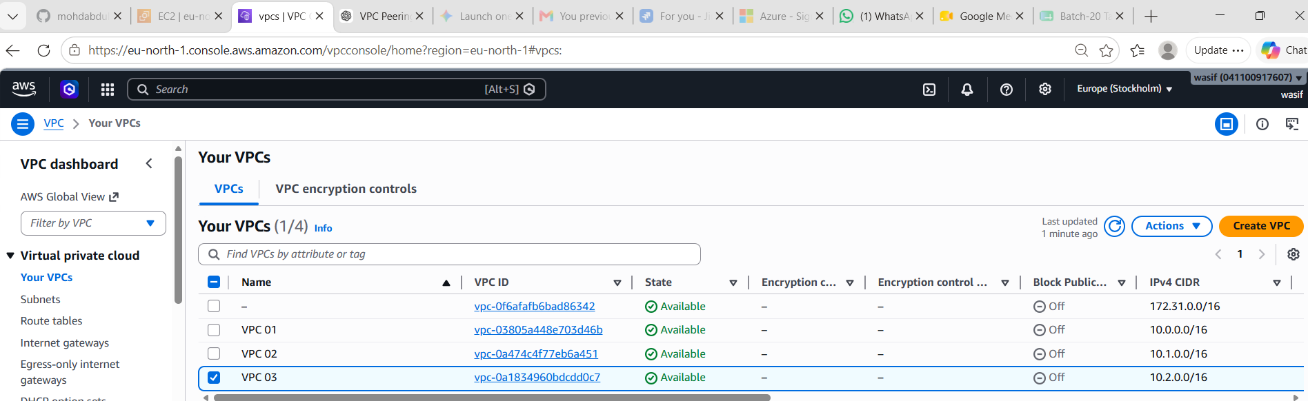

Created Subnets
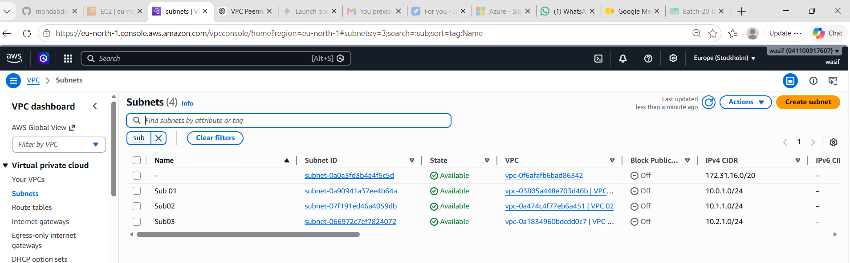

Step 4: Create Internet Gateways
For each VPC:
- VPC → Internet Gateways → Create
- Attach to respective VPC
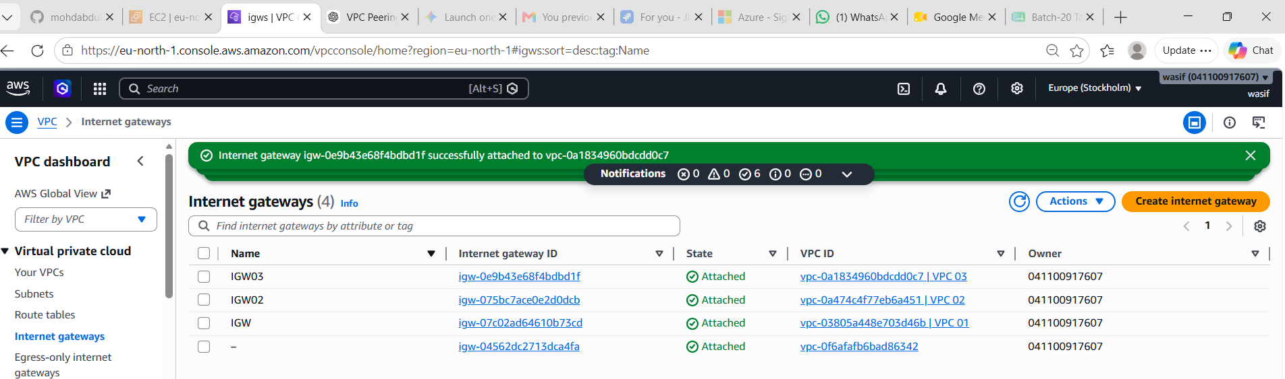

Step 5: Configure Route Tables
For each VPC Route Table add:
0.0.0.0/0 → Internet Gateway

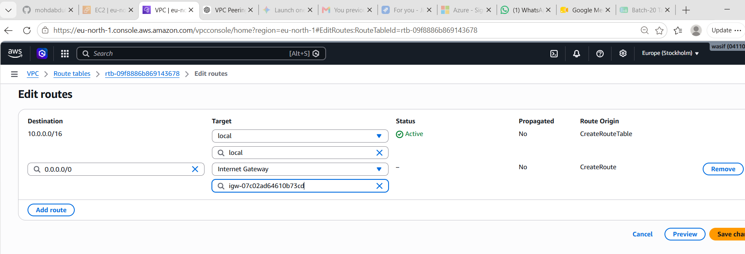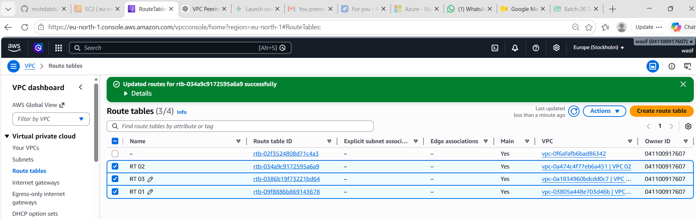
Step 6: Launch EC2 Instances
Launch 1 EC2 in each VPC:
- Amazon Linux 2023
- t3.micro
- Enable Public IP
- Security Group:
  - SSH (22)
  - ICMP
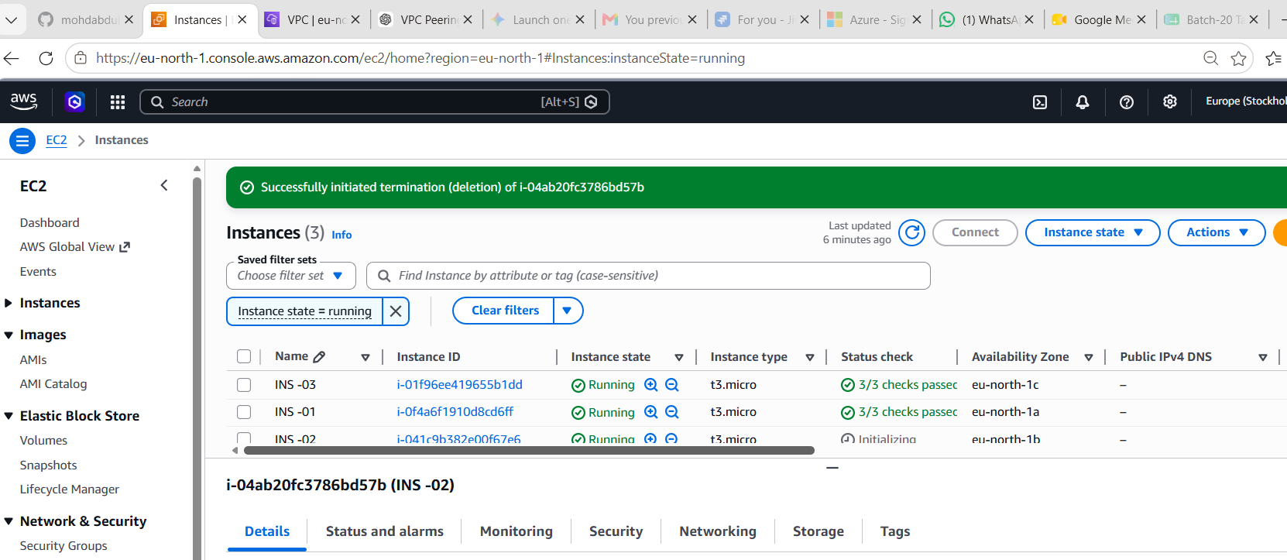

Step 7: Create Transit Gateway
- VPC → Transit Gateways
- Create Transit Gateway
Settings:
Name: My-TGW
DNS Support: Enable
Default Route Table Association: Enable
Default Route Table Propagation: Enable
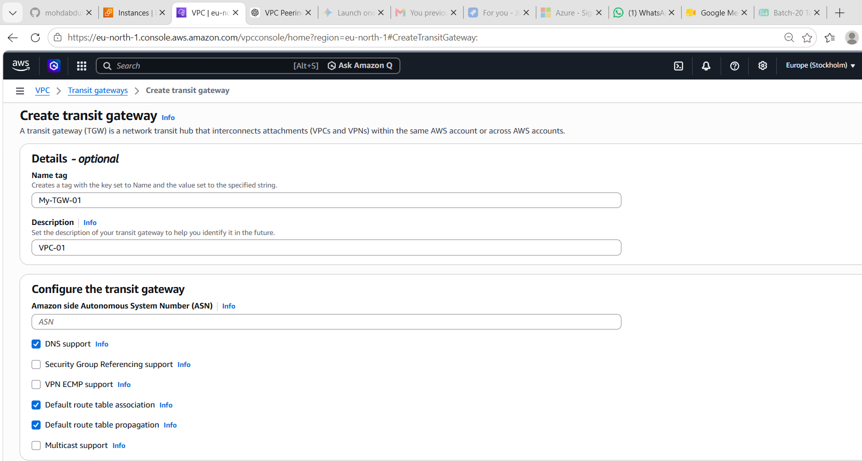

Step 8: Create TGW Attachment for VPC-1
- Transit Gateway Attachments
- Create Attachment
Select:
Attachment Type: VPC
Transit Gateway: My-TGW
VPC: VPC-1
Subnet: 10.0.1.0/24

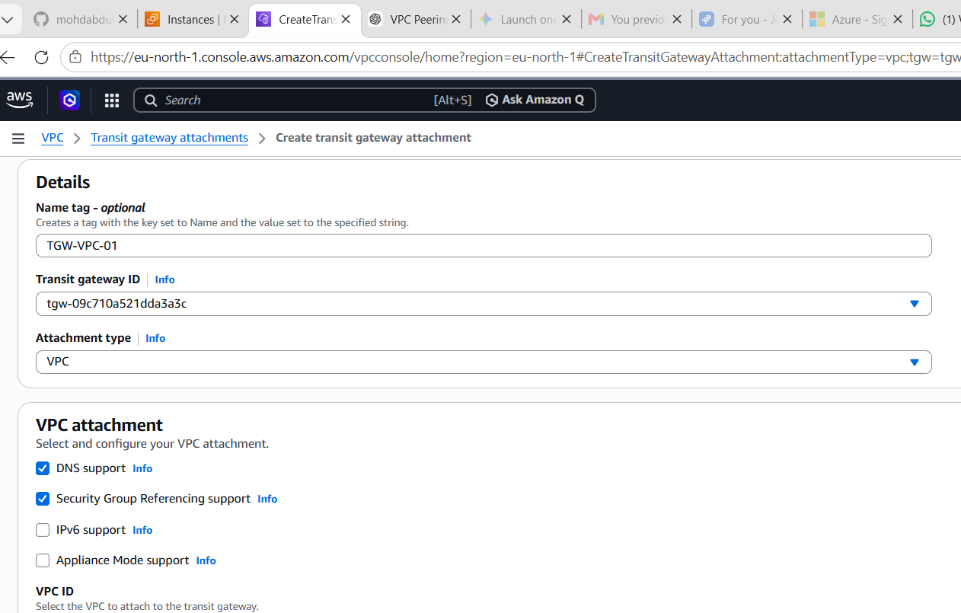

Step 9: Create TGW Attachment for VPC-2
Select:
VPC: VPC-2
Subnet: 10.1.1.0/24
Create.

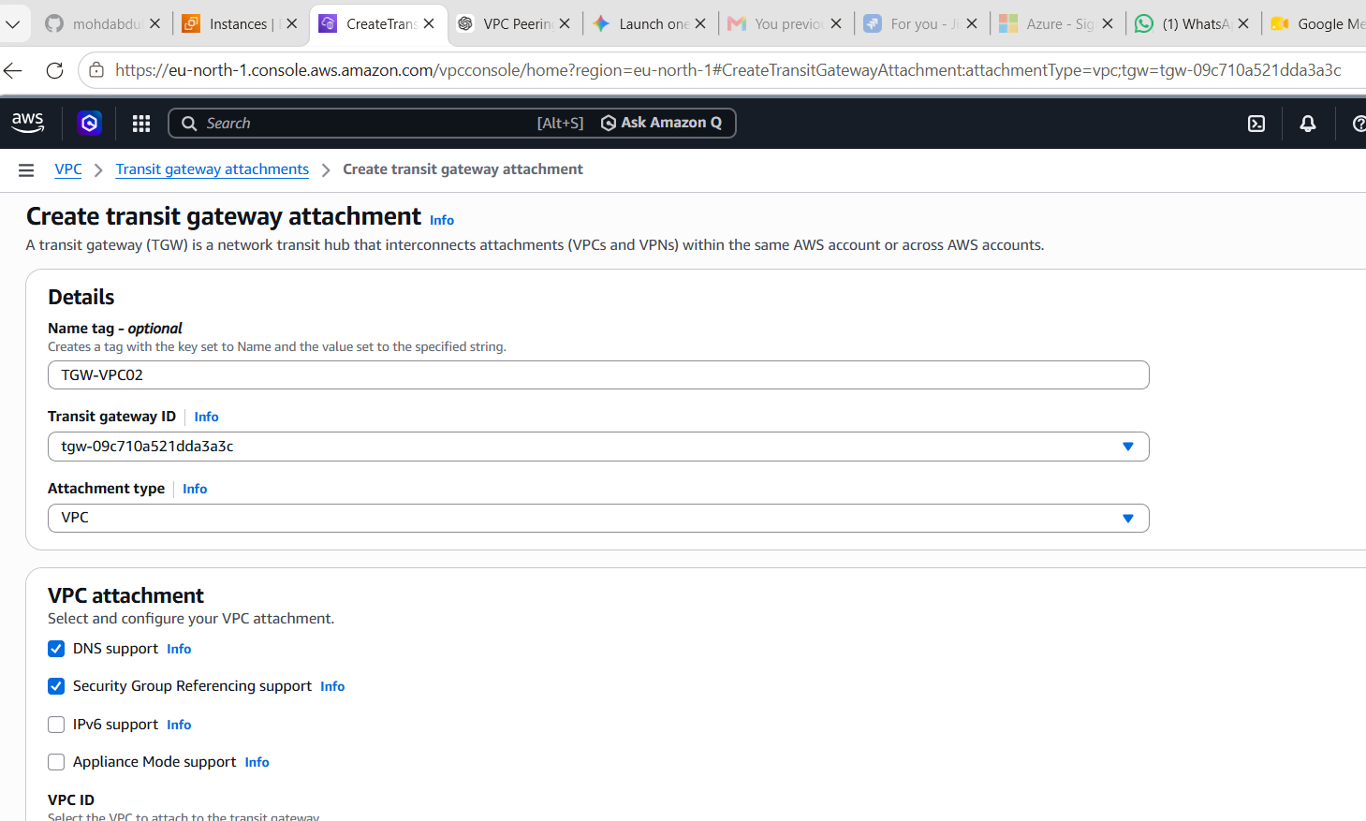

Step 10: Create TGW Attachment for VPC-3
Select:
VPC: VPC-3
Subnet: 10.2.1.0/24
Create.
Wait until all attachments show Available.
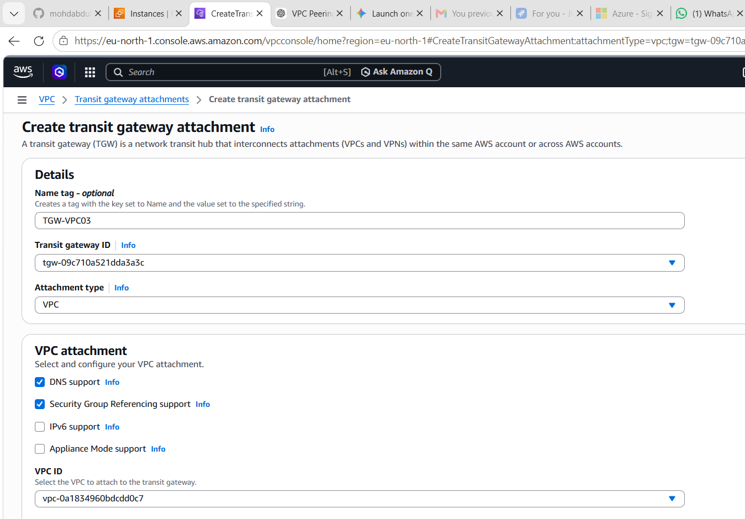

Endpoint created and attached VPC 01 and RT 01
Create VPC Endpoint for S3
Step 16: Create S3 Gateway Endpoint
- VPC → Endpoints
- Create Endpoint
Select:
Service Category: AWS Services
Service Name: com.amazonaws.eu-north-1.s3
Endpoint Type: Gateway

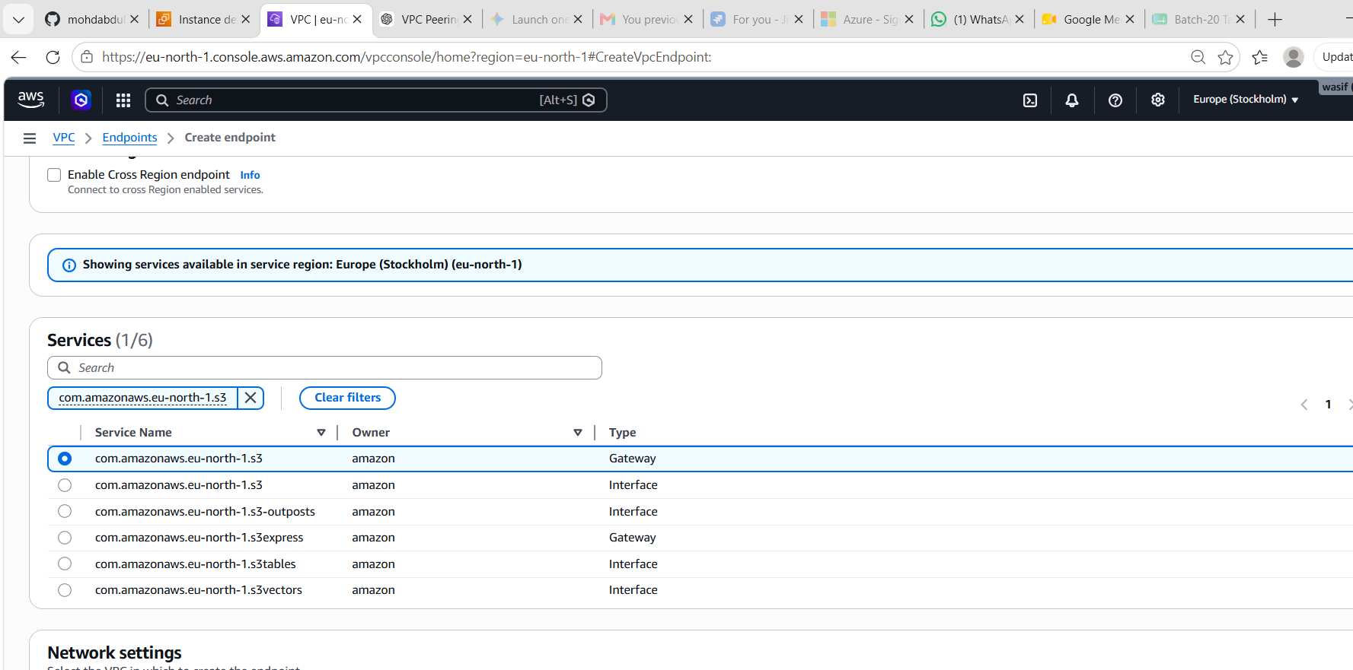
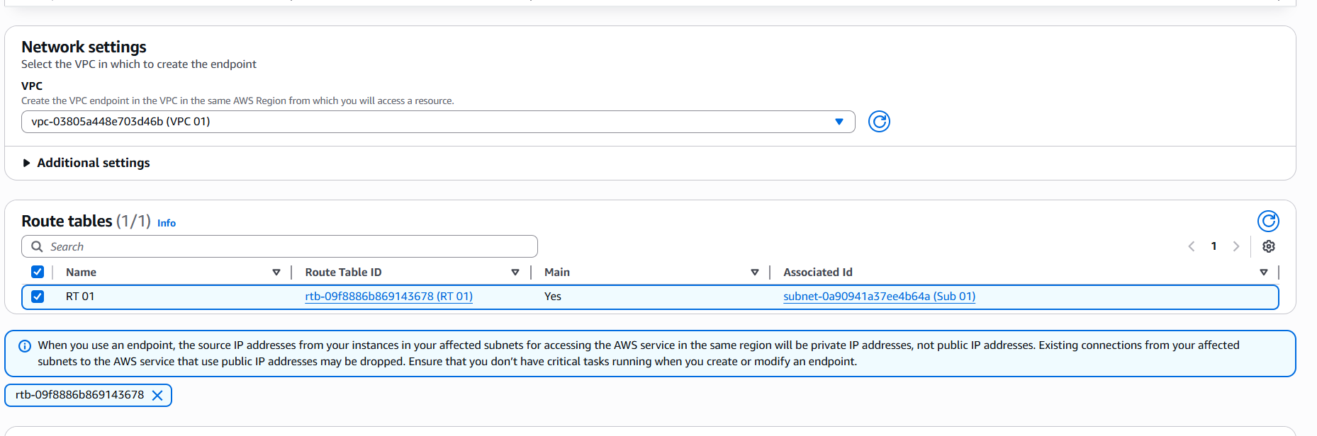
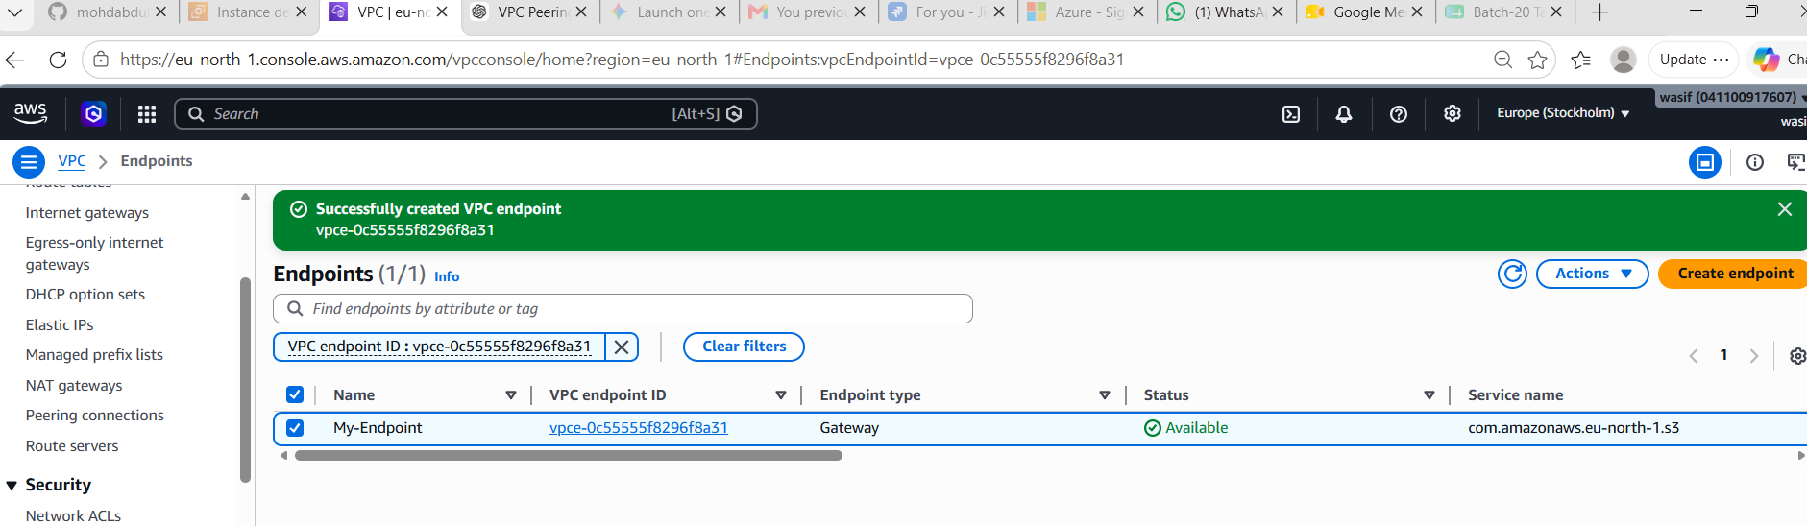

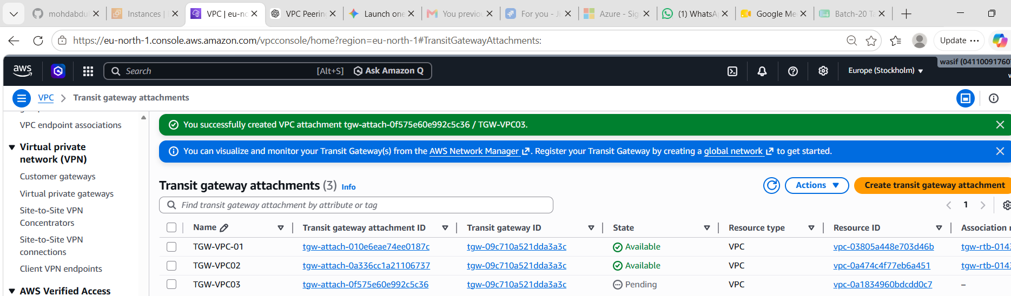
Step 11: Update Route Table of VPC-1
Add routes:
10.1.0.0/16 → Transit Gateway
10.2.0.0/16 → Transit Gateway
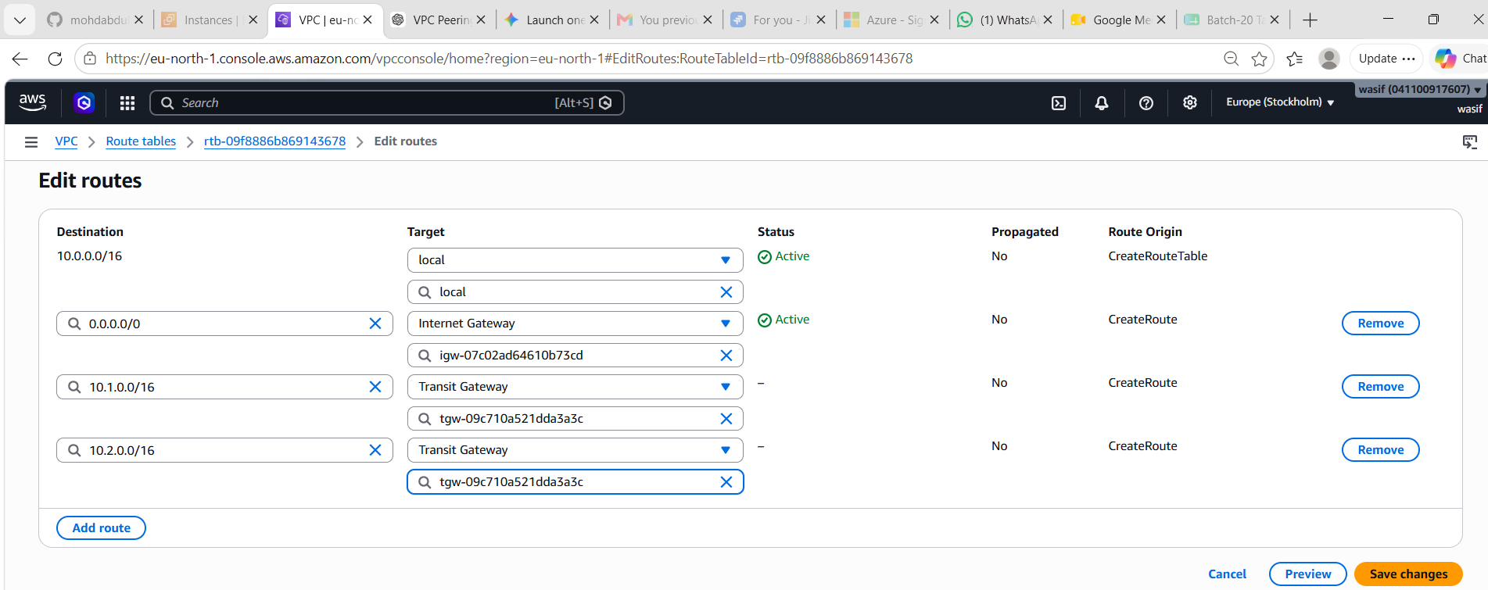
Step 12: Update Route Table of VPC-2
Add routes:
10.0.0.0/16 → Transit Gateway
10.2.0.0/16 → Transit Gateway

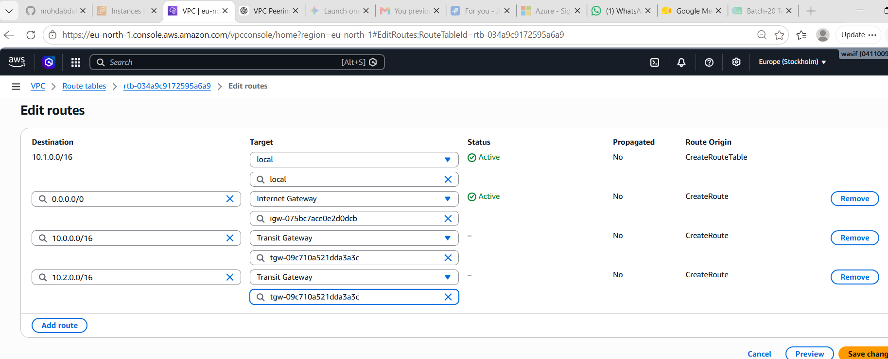

Step 13: Update Route Table of VPC-3
Add routes:
10.0.0.0/16 → Transit Gateway
10.1.0.0/16 → Transit Gateway
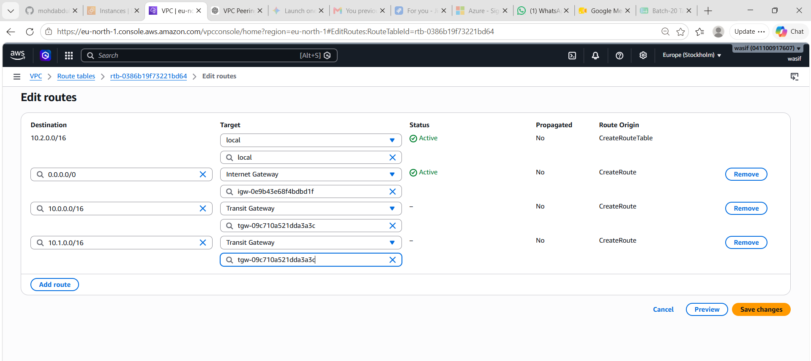

Checked in 1st instance with 2 and 3rd Private id
Step 15: Test Transit Gateway
SSH to EC2 in VPC-1:
ping <Private-IP-of-VPC2-EC2>
ping <Private-IP-of-VPC3-EC2>
Ping should succeed.
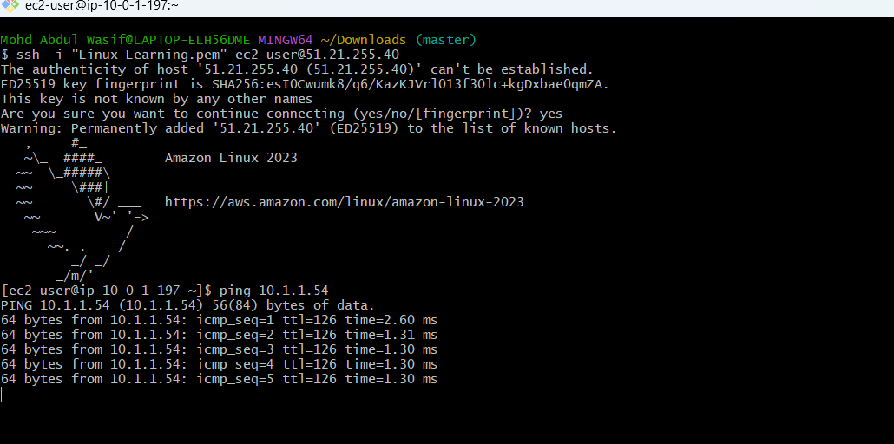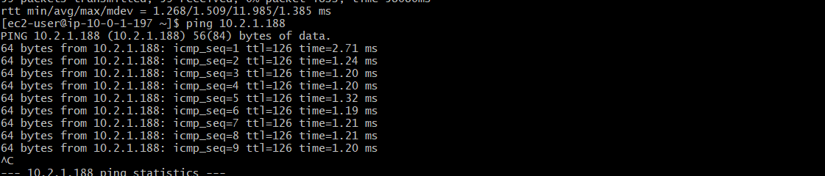
Got Error for S3

Created IAM s3 role
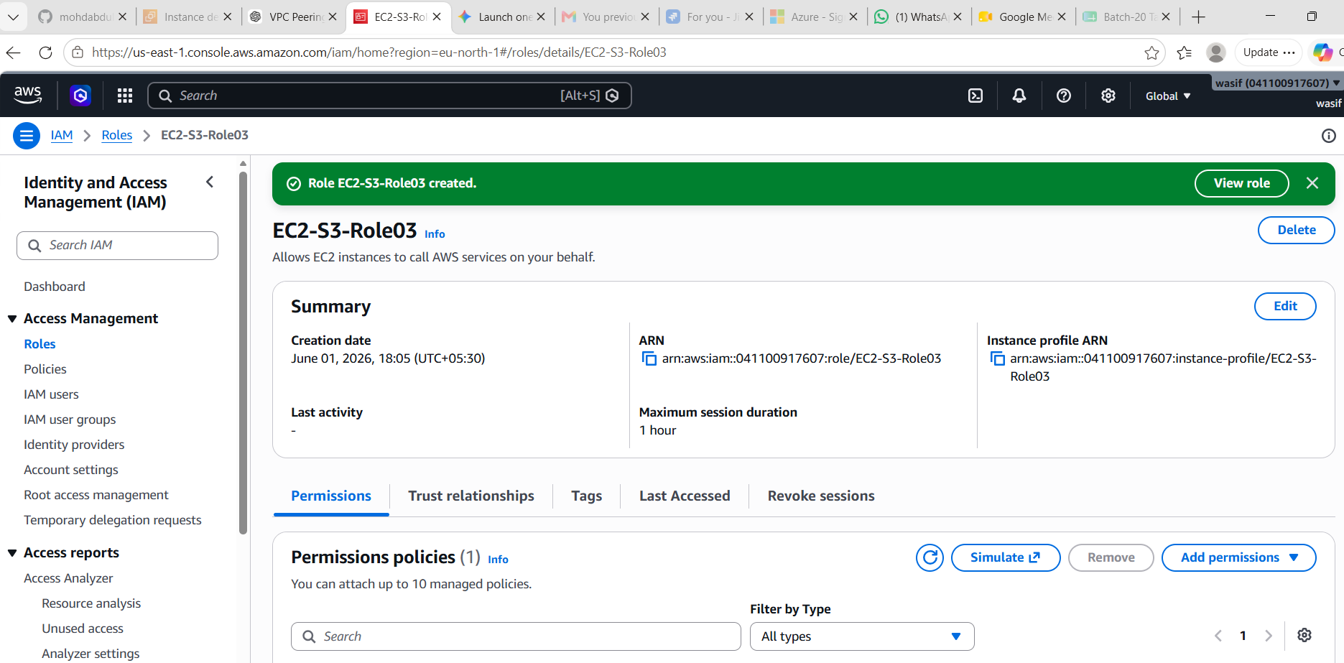
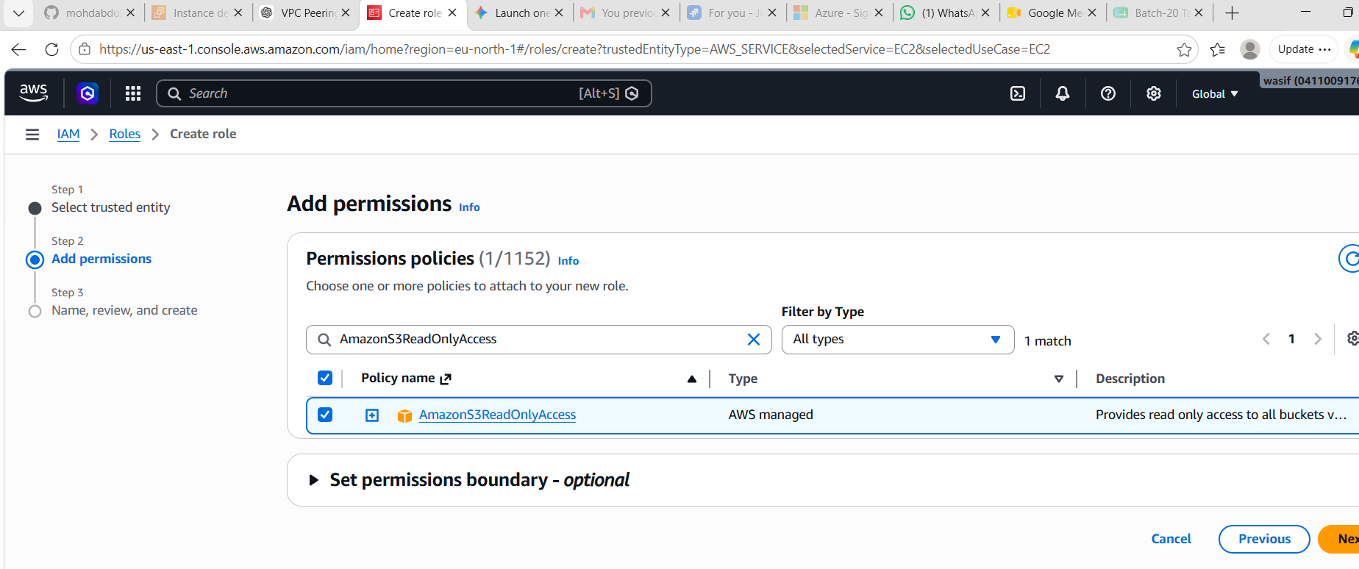
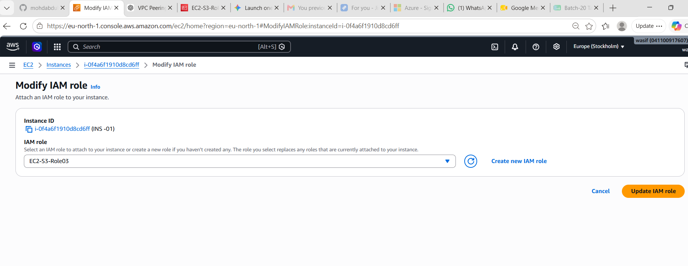
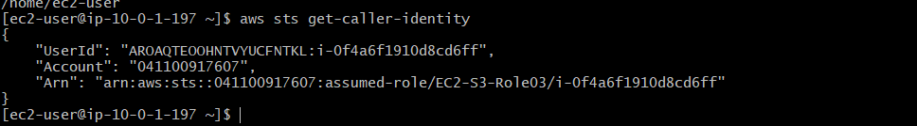

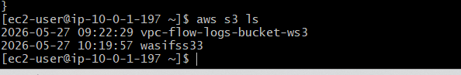

This confirms:
✅ IAM Role is attached to the EC2 instance
✅ EC2 has permission to access S3
✅ AWS credentials are being provided through the IAM Role
✅ S3 access is working
To fully complete the VPC Endpoint task, verify:
- S3 Gateway Endpoint is created
  - VPC → Endpoints
  - Status = Available
- Endpoint is associated with the correct Route Table
  - The route table used by your EC2 subnet should be selected in the endpoint configuration.
- S3 access works
  - Already verified with aws s3 ls ✅
Result (for documentation)
Result: Successfully configured an S3 Gateway VPC Endpoint and attached an IAM role to the EC2 instance. The EC2 instance was able to access Amazon S3 privately using aws s3 ls, demonstrating secure access to AWS services without requiring credentials on the instance.
What We Learned
- Created and attached an IAM Role to an EC2 instance.
- Configured a VPC Endpoint for Amazon S3.
- Enabled private access to S3 from within a VPC.
- Verified connectivity using the AWS CLI.
- Reduced dependency on Internet/NAT Gateway for S3 access.
If your assignment is "Setting up Transit Gateway and VPC Endpoints for a Multi-VPC Architecture", then make sure you have also:
- Created the Transit Gateway ✅
- Attached all required VPCs to it ✅
- Updated route tables for TGW communication ✅
- Verified EC2-to-EC2 connectivity across VPCs ✅

